Task on CloudFront & Route 53

1. Configure VPC peering in cross regions.

This is for one regions

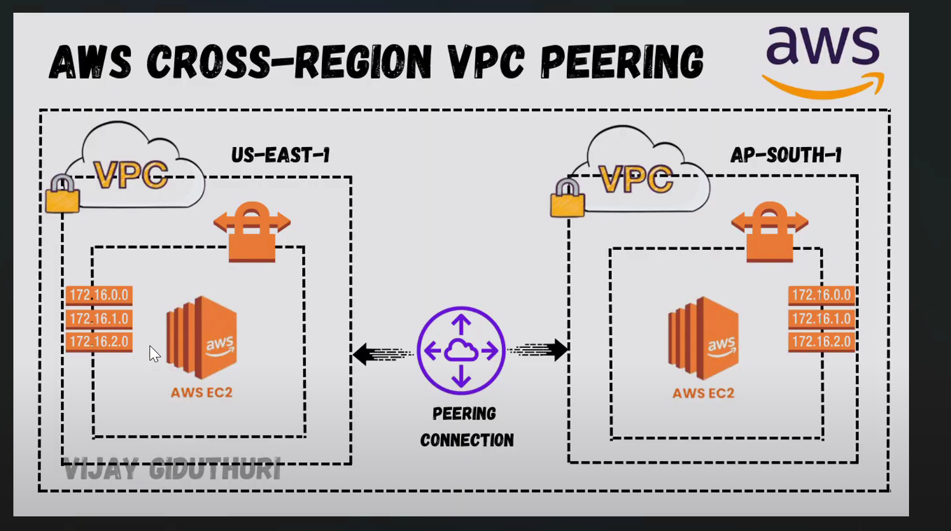

Create a VPC, name it my-vpc1

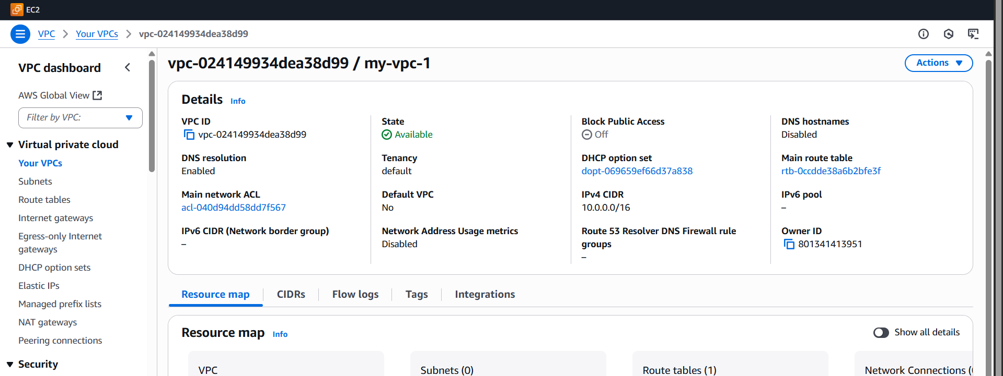

Create one IGW and attach to vpc

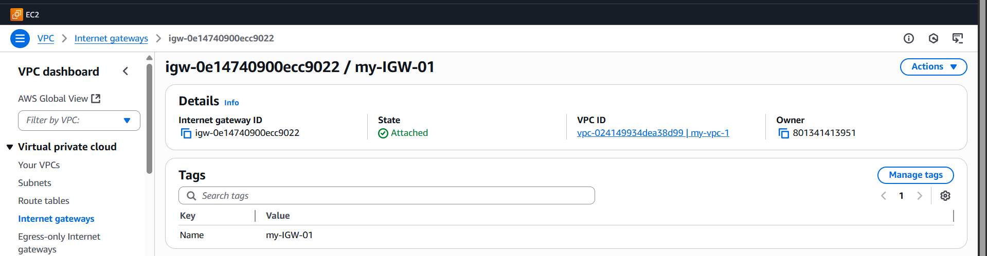

Create one subnet

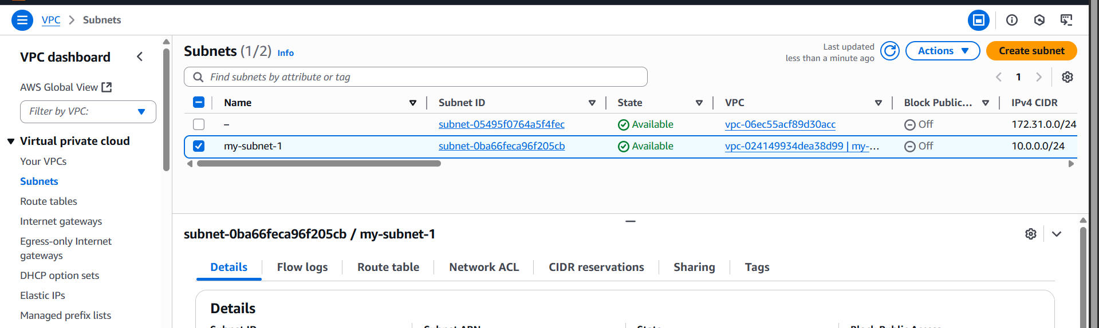

Create one route table

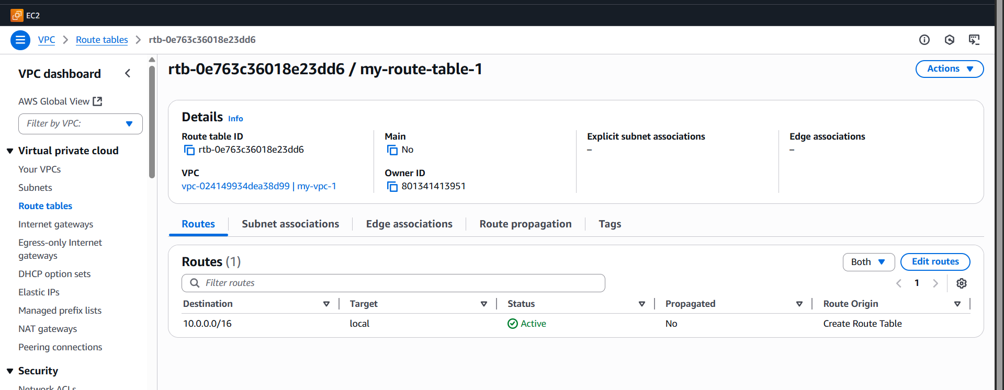

In the route table associated with subnet 1  
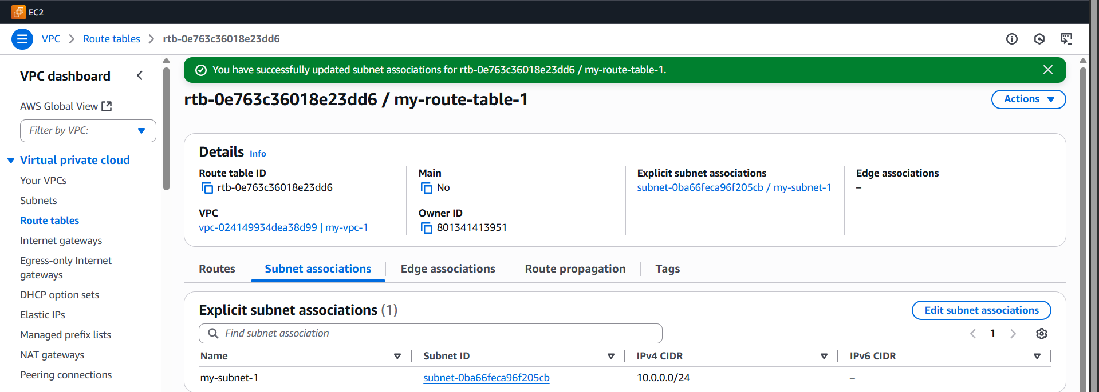

Add in the route table internet gate way   
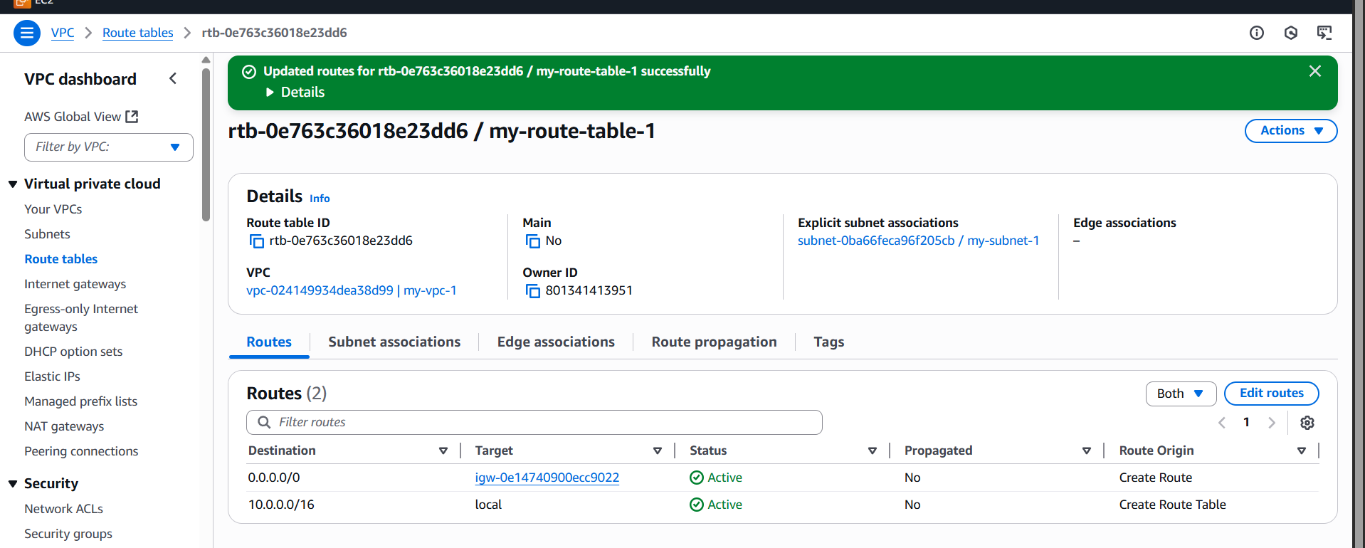

This is what we have done in one region

**Now we are going to do the 2nd region**



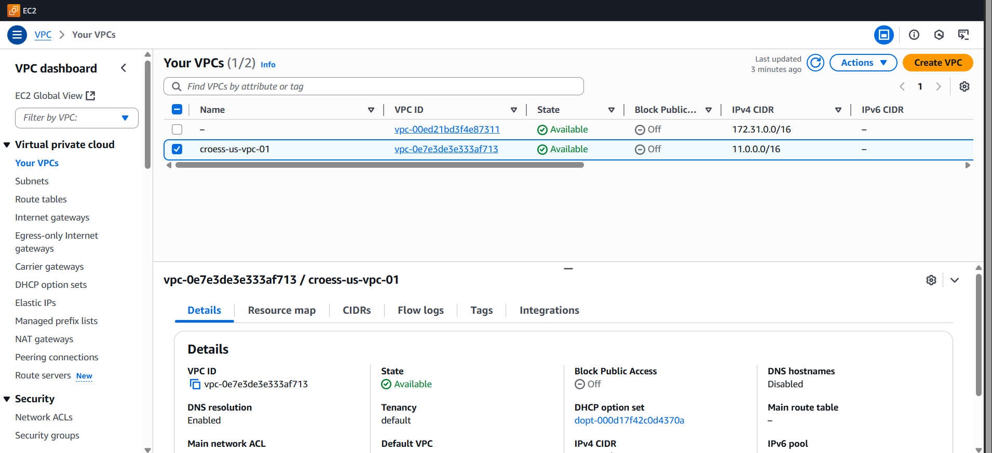

Create one subnet

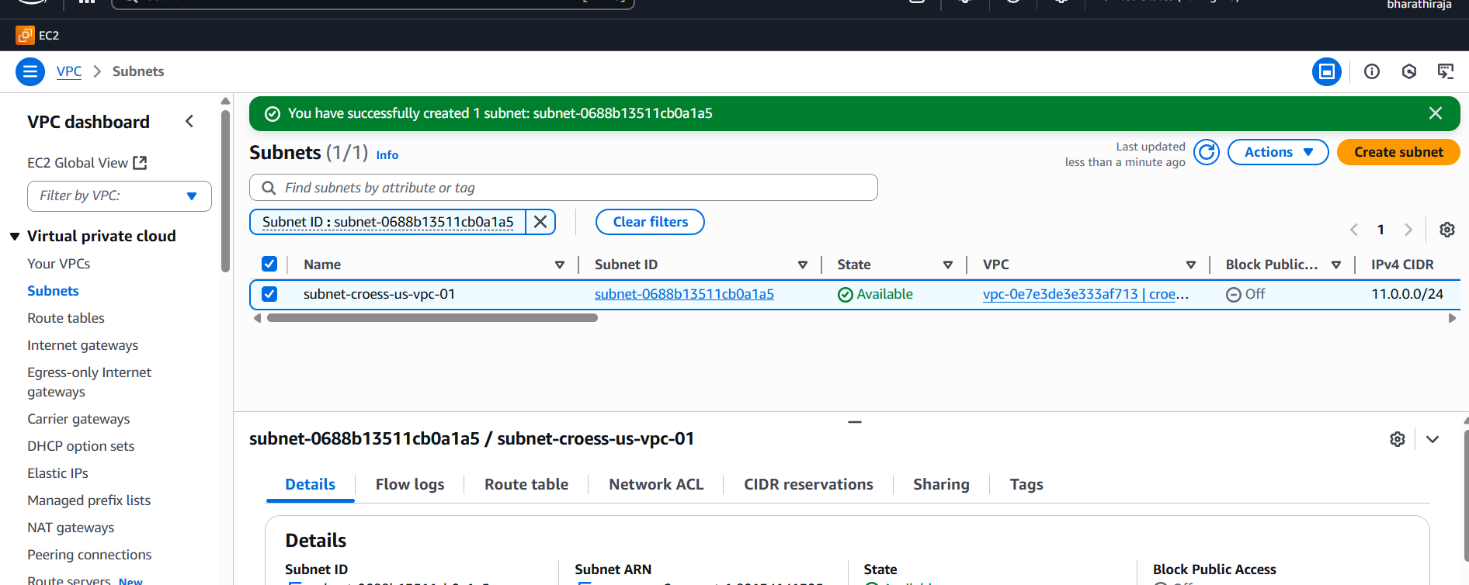

Create one IGW and attach it to the VPC

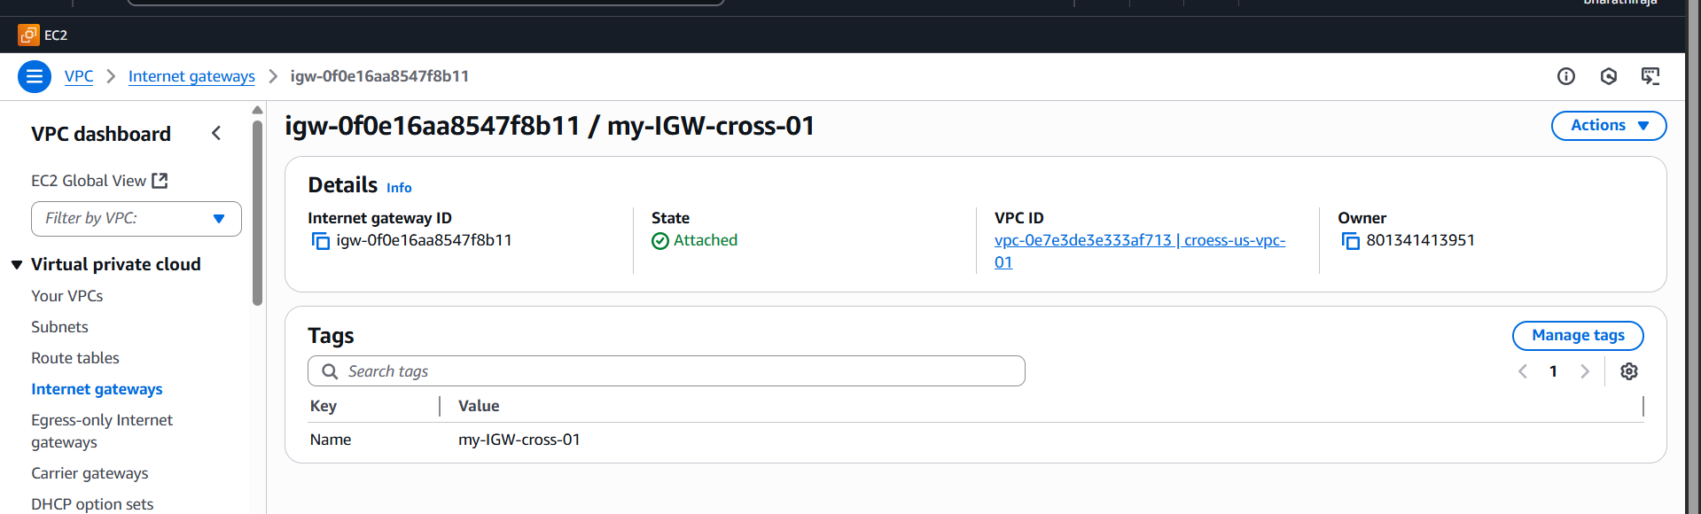

Create route table and attach it to associate with the subnet

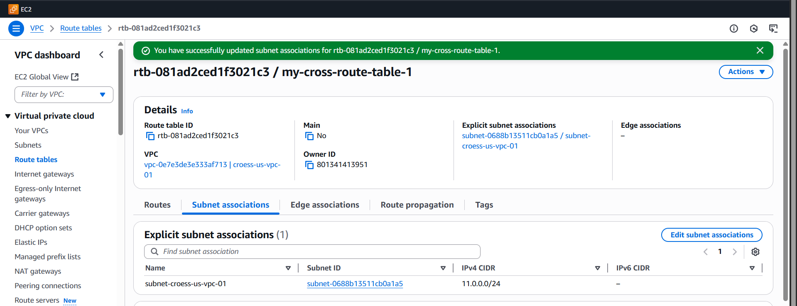

Attach it to the route table to the IGW ALSO

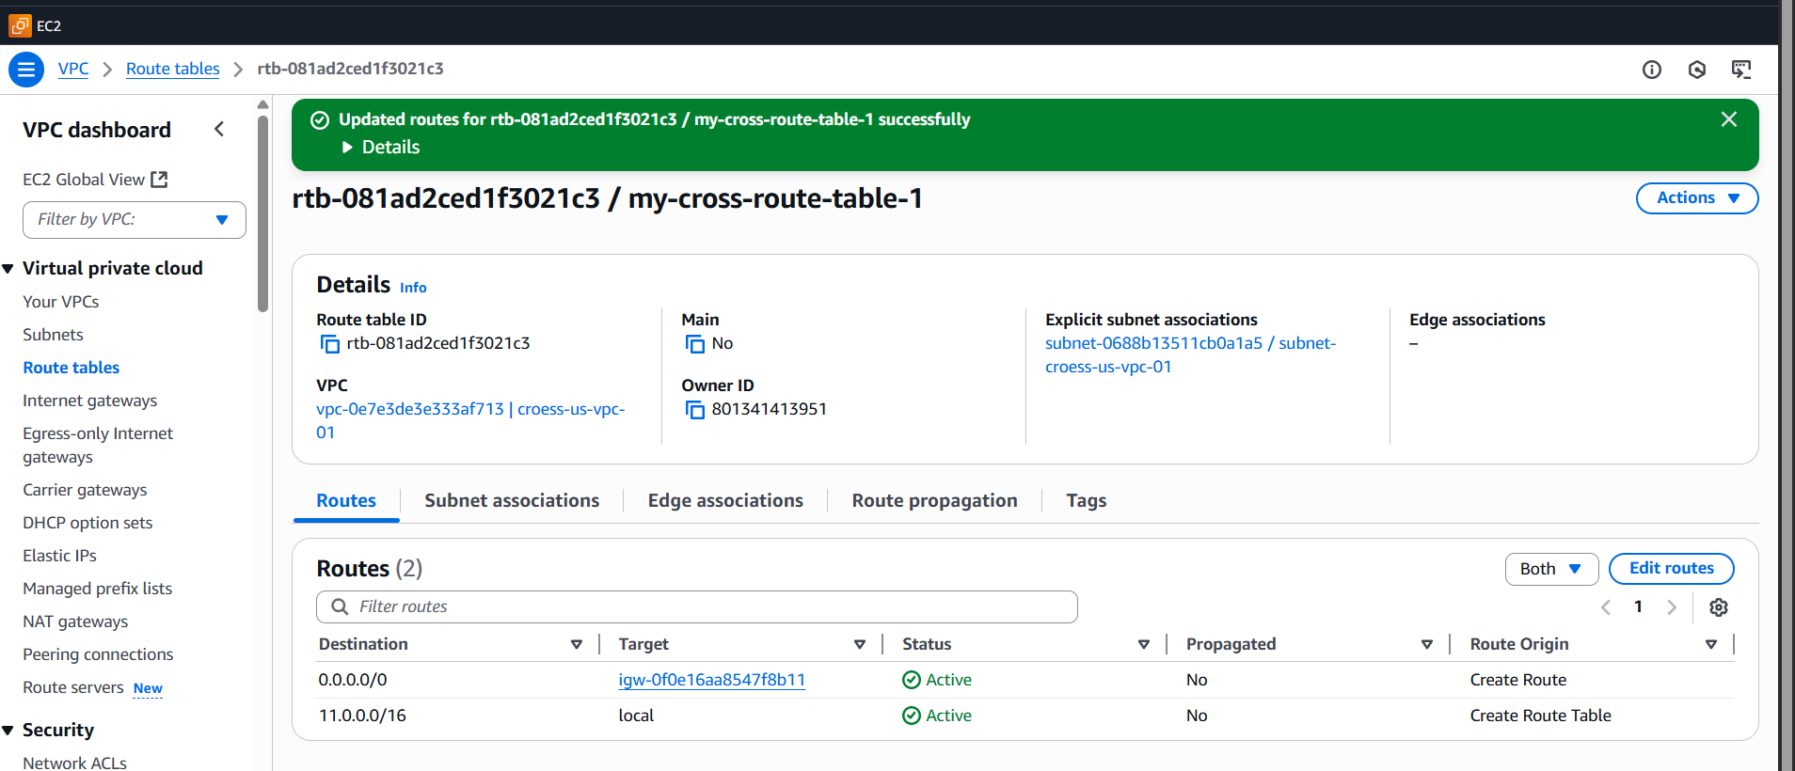

Connect 2 EC2 instances

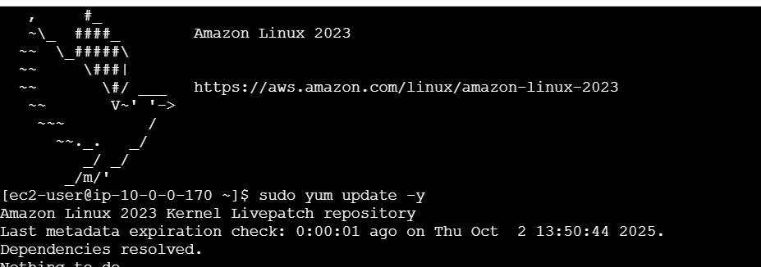

Ip a => check ip address  
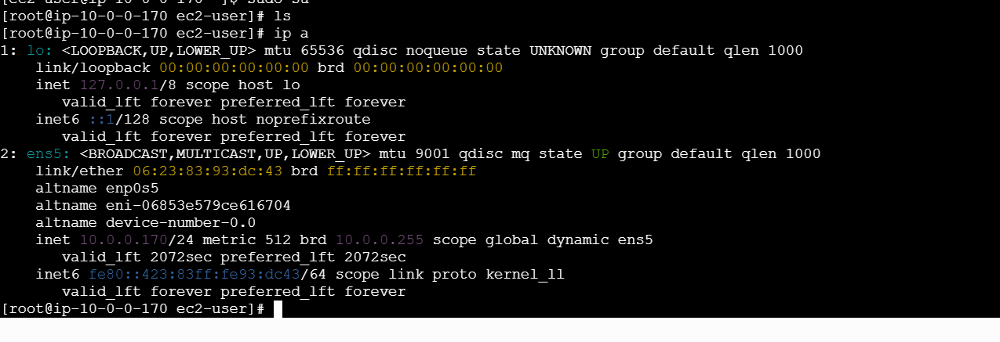

This ec2 instance

While opening

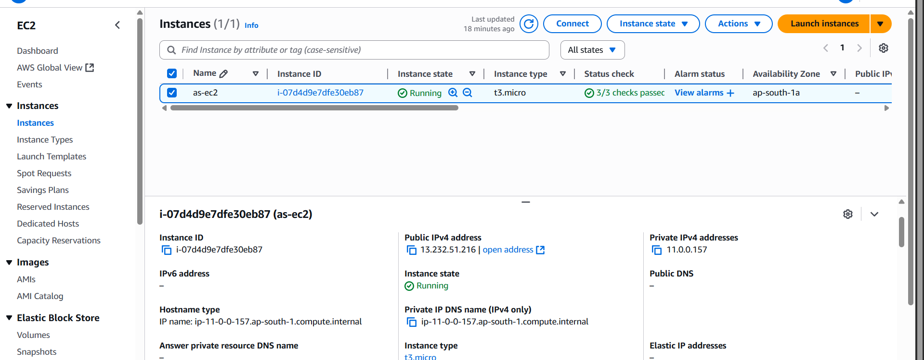

Checking IP

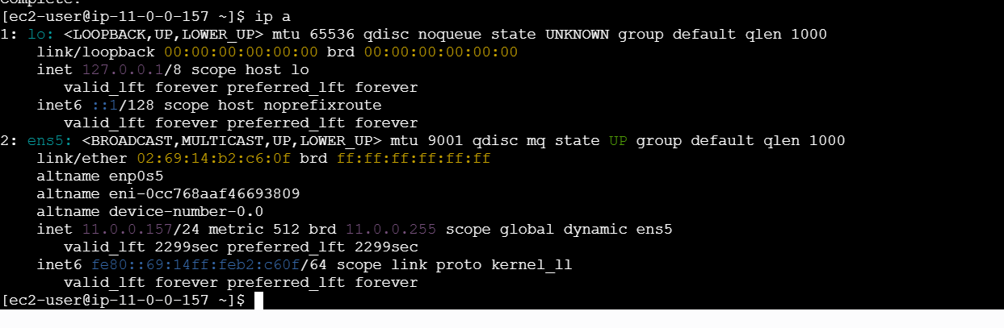

Private ip doenot work

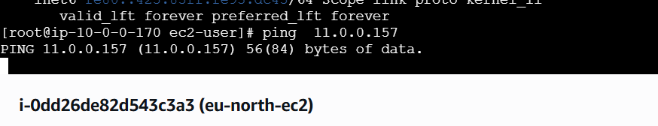

After change

Create one VPC peering and add VPC ID and accept a+  
then add

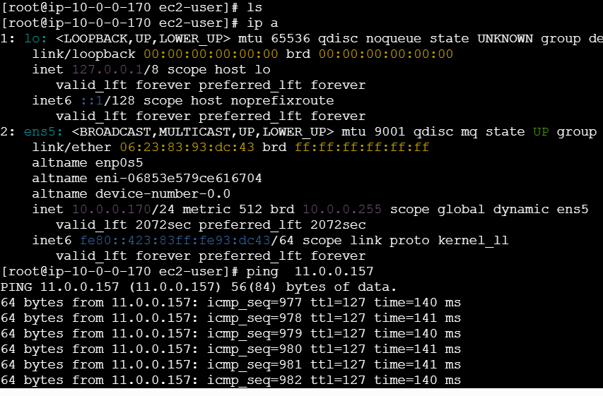

1. Purchase one domain from GoDaddy.

Purchased one doamin

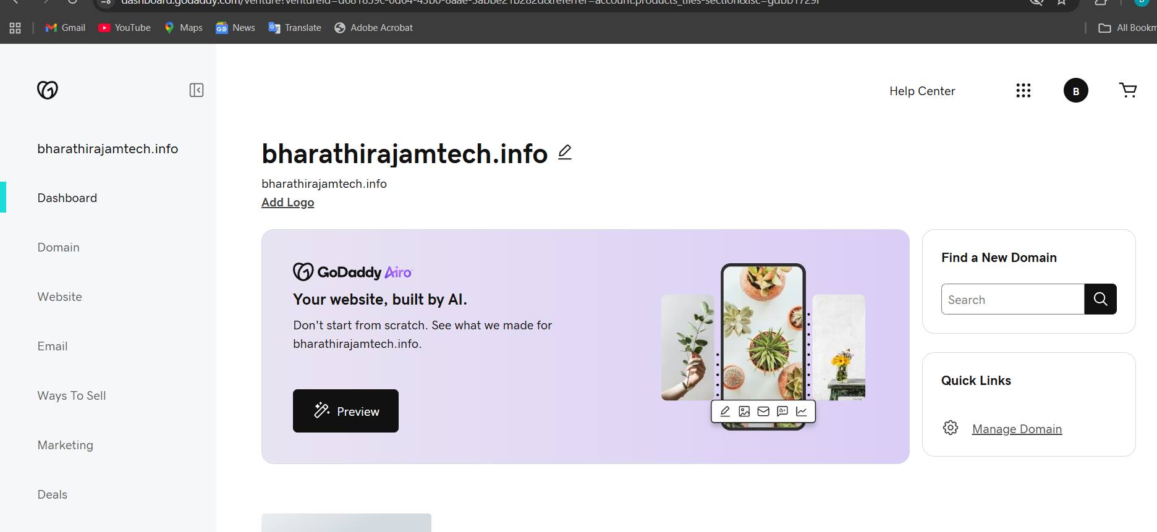

1. Deploy a static website in S3.

Create a bucket   
Add a file that is going to be deployed

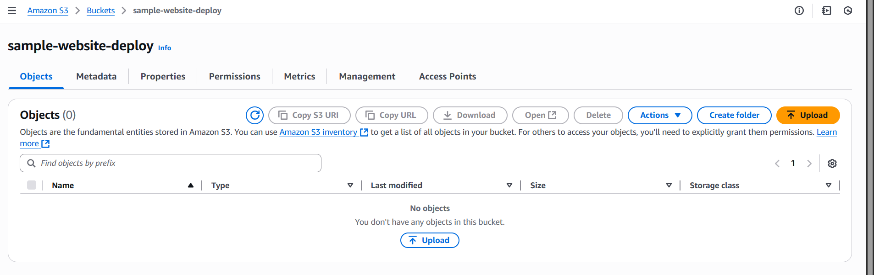

Add the file   
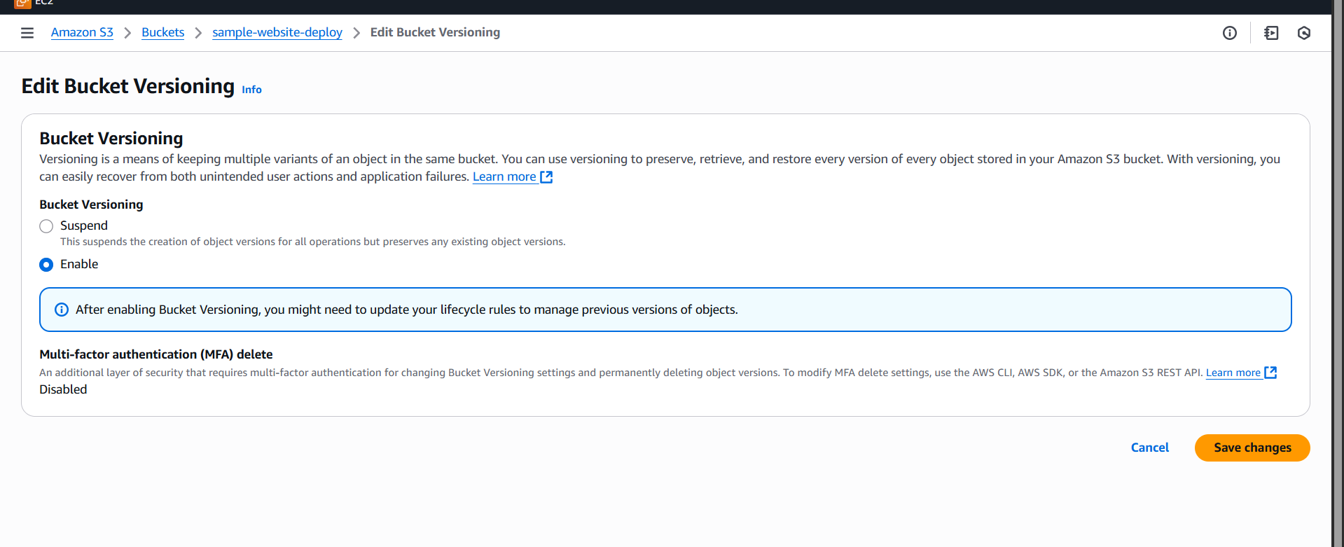

After adding the file, make the public

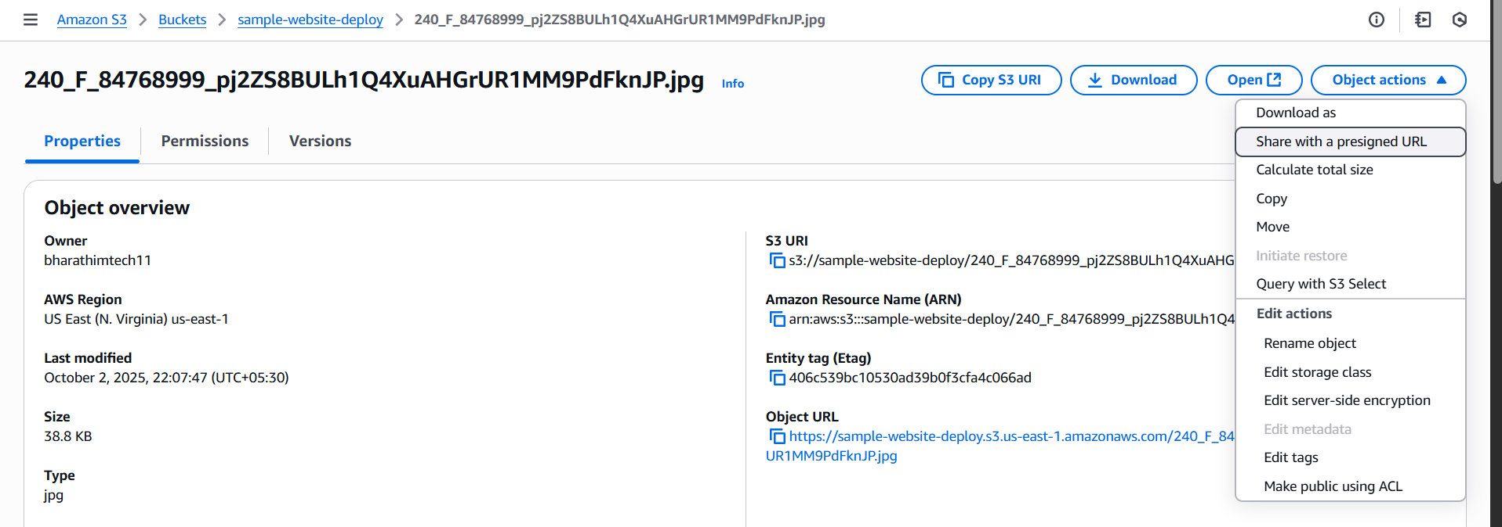

And paste in to the browser:  
Here the results are for index.html>>>>>

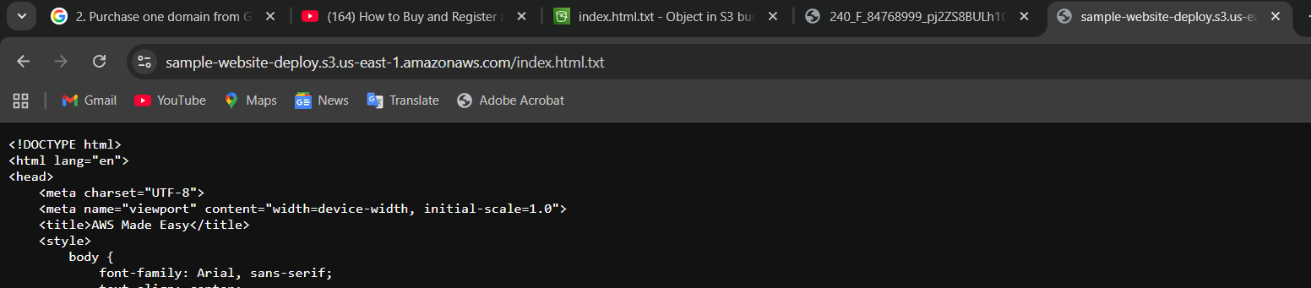

1. Create a CDN and attach one SSL certificate.

Create this page AWS console

Go to the certificate part 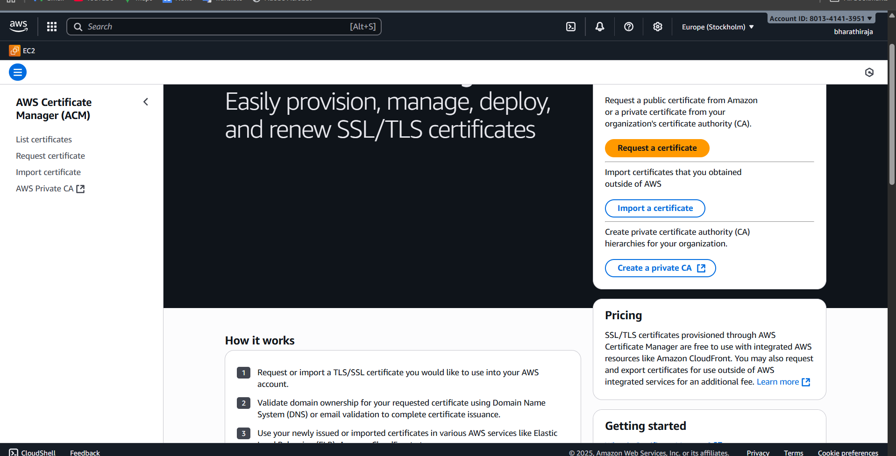

Then a request a certificate specially   
we purchased on certificate

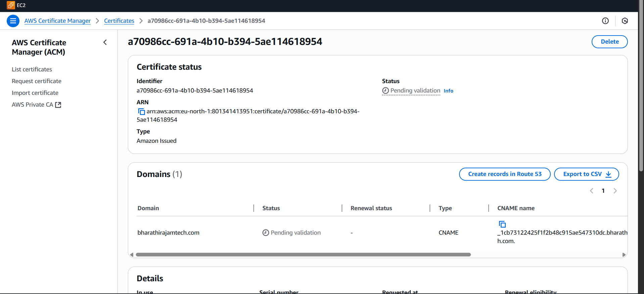

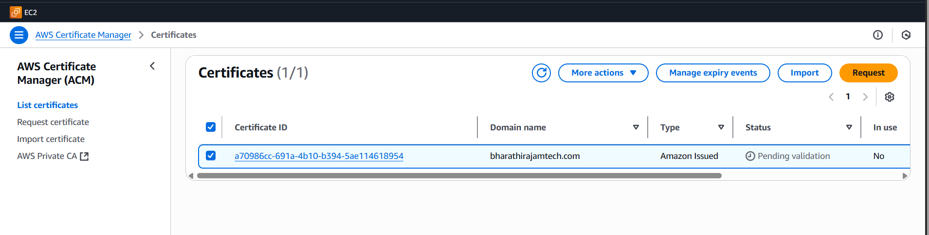

Created cloudfront one

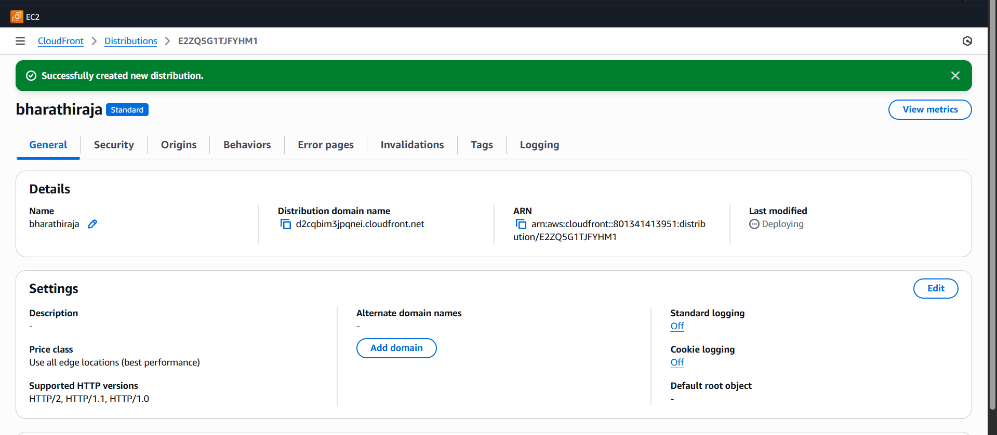

**Create one record   
it will appear our what we have created**

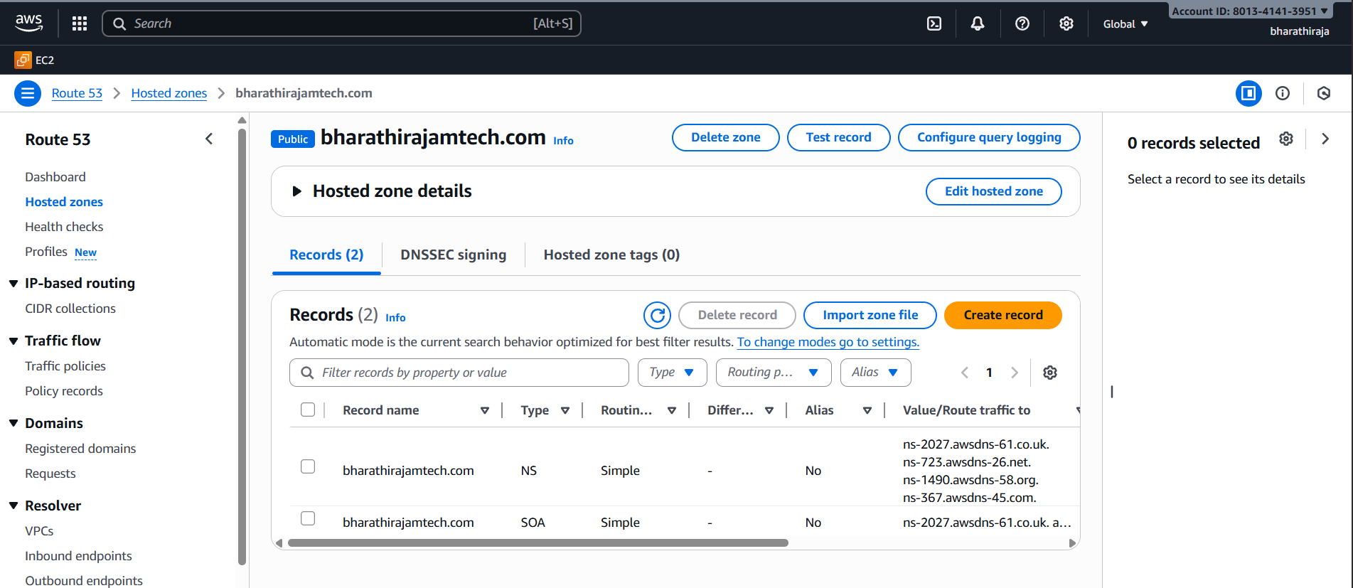

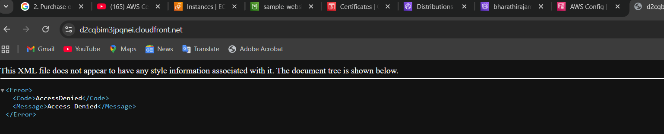

**We had done the configuration with GoDaddy**

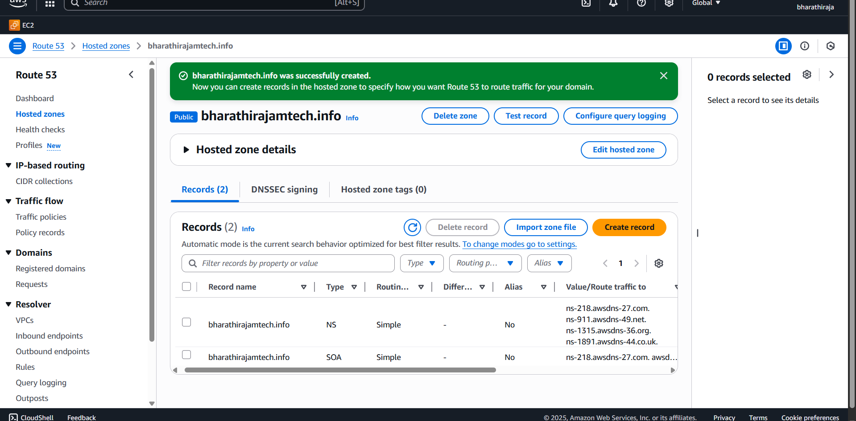

**Create a bucket same domain name**

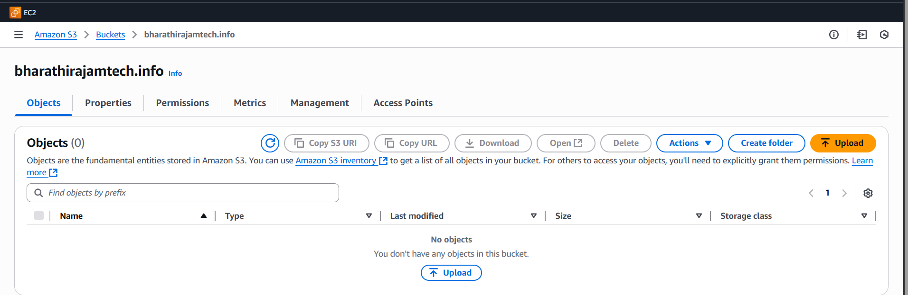

1. Create a Route 53 hosted zone and map the domain with the CDN.

Go to the aws console.  
¬Then go to the route 53 nd creating record.  
¬And it will gave uh a four websites and go to the   
go daddy website.  
¬Where you purchase go daddy.  
¬Open a website and edit DNS name servers.  
¬Copy the four DNS websites.  
we can find 4 diffrent domain

ns-218.awsdns-27.com

ns-911.awsdns-49.net

ns-1315.awsdns-36.org

ns-1891.awsdns-44.co.uk

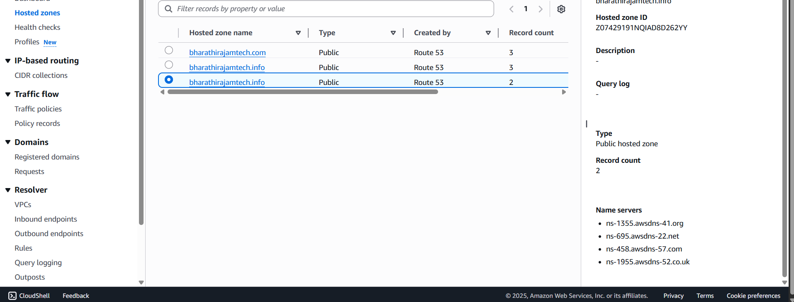

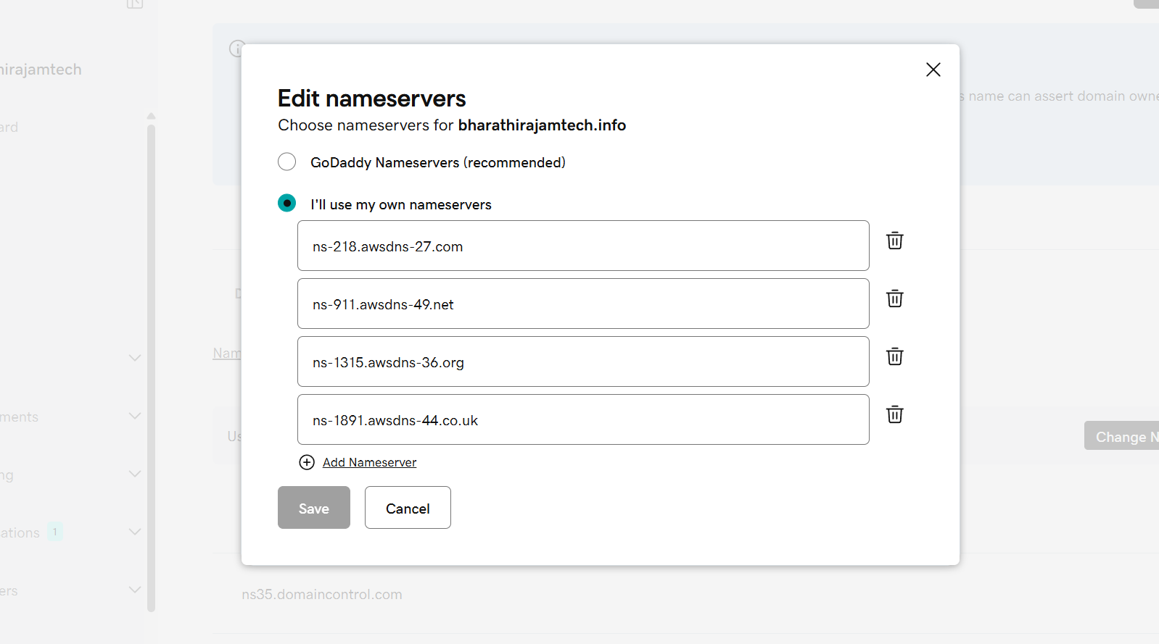

1. Update the index.html in the S3 bucket and ensure the updated file is accessible using the domain name.

Go to the cloud front distribution.

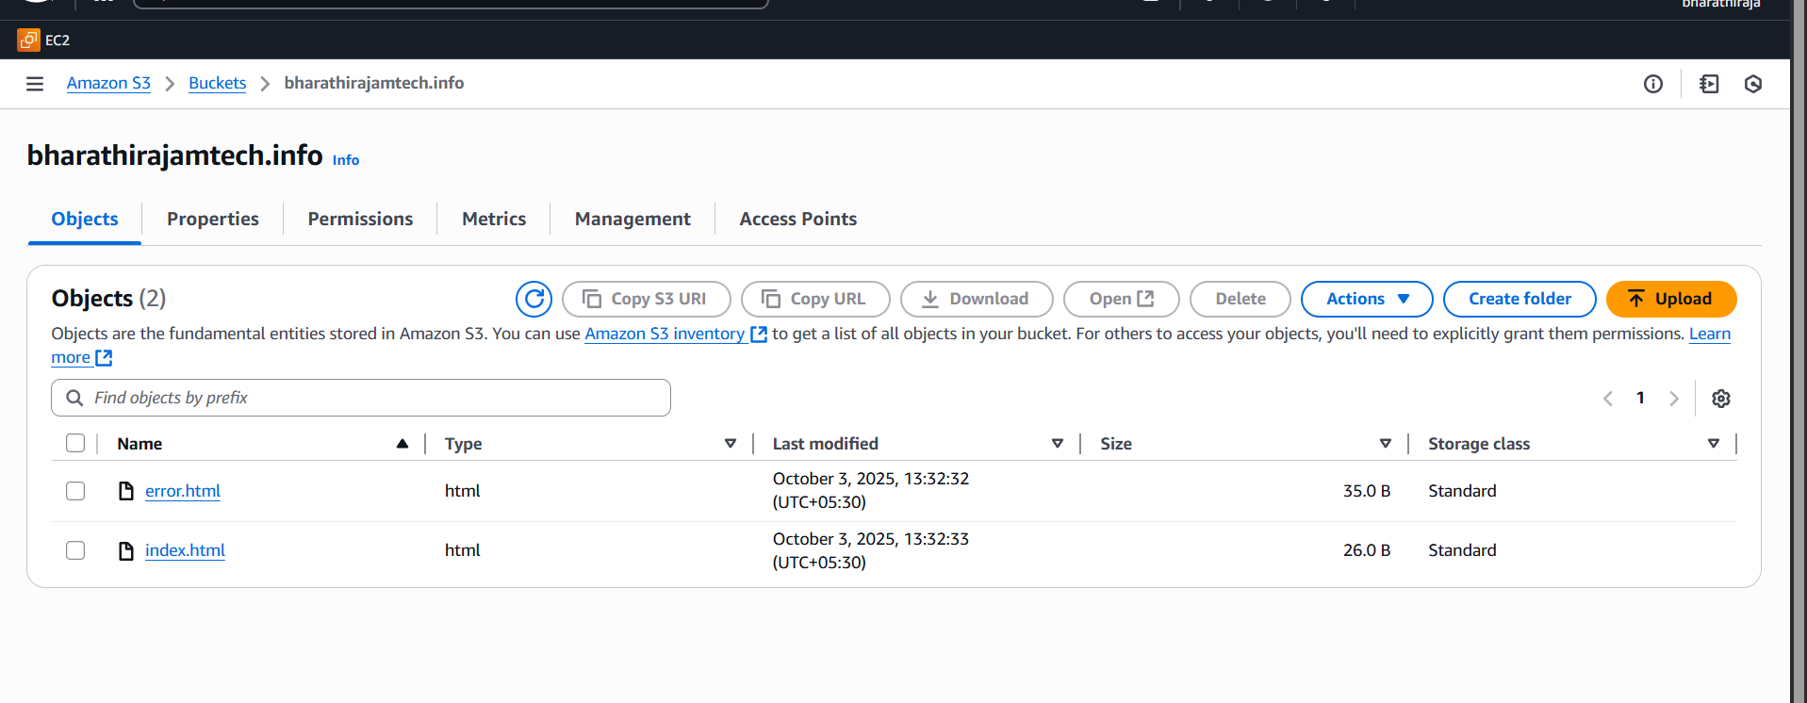

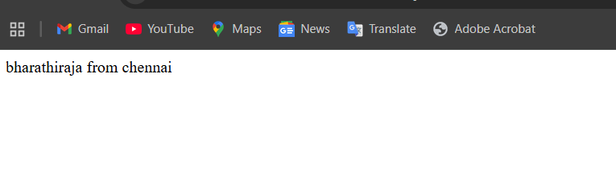

1. Share the domain name in Slack to test the connectivity.

https://bharathirajamtech.info